

KREIDER SERVICES, INC.

Job Description

Job Title: Director of Programs Prepared by: VP Clinical Svs & Prog

Department: Programs Prepared Date: 11/18/20

Reports to: VP Clinical Services & Programs Approved by: JScholl

FLSA Status: Salary Approved Date:

Salary Range:

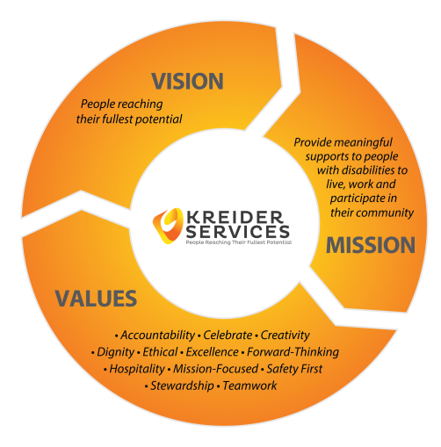

PHILOSOPHIES THAT GOVERN THIS JOB

* We are client focused
* We pursue the capabilities of each individual
* We teach appropriate choice and independence
* We provide an atmosphere free of discrimination, abuse and neglect
* We treat individuals with dignity and respect.
* We promote an atmosphere of learning

GENERAL JOB DUTIES

Directs the overall operation of all adult programs through the supervision of Managers, ensuring the highest quality of services are provided. Works as a member of the Executive Team to provide direction to the agency. Works as a member of the Managers team to provide the tools necessary for staff to teach the individuals we support independence, emphasizing the capabilities of the individuals we serve.

ESSENTIAL JOB DUTIES

1. Provide leadership and direction to the managers and other staff that report to the position, communicating information flow between the agency and them.
2. Facilitate and lead communication meetings between Clinical Services and Program leadership staff.
3. Communicates with leaders of other departments to integrate services.
4. Evaluate programs routinely to assure compliance to standards of Illinois Departments of Public Health, Healthcare and Family Services, Department of Humans Services, and its Division of Developmental Disabilities,, Department of Labor and accrediting bodies as applicable.
5. Monitor the financial operation of all programs, promoting efficiency and effectiveness.
6. Review, revise and update policies and procedures that effect program areas specifically.
7. Routinely assess individuals we support, and their needs and make recommendations to improve person-centered focus along with technology integration within the agency.
8. Communicate regularly with program staff to assess concerns and issues, then make recommendations to the Executive team on how to handle situations.
9. Evaluates the programs regularly to ensure that human, civil, and employment rights are safeguarded, and that people are treated with the highest level of respect and dignity.
10. Represents Kreider Services at statewide, and national organizations, such as IARF, and ANCOR, and other organizations as assigned.
11. Plan, organize and monitor the opening of any new residential programs within the department.
12. Provides for emergency situations by acting as Administrator on duty on a rotating basis.
13. Write and submit requests for the designated 708 Boards, United Way, and others.
14. Participate in agency committees.

ADDITIONAL JOB DUTIES

Other duties as assigned.

QUALIFICATIONS

Must be able to work as a team leader and member. Must be assertive in pursuit of Kreider's view of standards. Must have excellent communication and supervisory skills. Must be able to manage multiple projects at the same time. Experience in supervision, management, and Developmental Disabilities required. Degree in Human Services or Management required, Master's preferred. Valid driver license and driving record acceptable to Agency insurer.

PHYSICAL DEMANDS

Scheduled weekday hours, frequently over 40 hours/week, and occasional evening/weekend. Frequently travels within state. Exerting up to 10 pounds of force occasionally and/or a negligible amount of force frequently or constantly to lift, push, pull or otherwise move objects. Sedentary Work involves sitting most of the time. Must be able to, reach, finger, grasp, talk, hear, and complete repetitive motions. Visual activity requirements include preparing and analyzing data and figures, accounting, computer terminal, extensive reading, or visual inspection. Works in well ventilated/lighted area.

The work environment characteristics described here are representative of those an employee encounters while performing the essential functions of this job. Reasonable accommodations may be made to enable individuals with disabilities to perform the essential functions.